Hanging Rock Christian Camp
Dining Hall Attendant
Job Description 2026
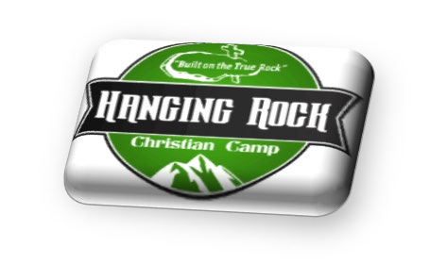
Reports to:
Associate Director

Responsibilities: You will be responsible for maintaining both dining halls during each meal.

Duties: To include but not limited to the following
- Stock dining hall for each meal: salad bar, drink station, napkins, salt & pepper, condiments, etc.
- Clean dining room: wipe tables, straighten chairs, sweep, mop, and remove trash after each meal.
- Assist with dishes if/when needed
- Assist with stocking shelves after deliveries
- Prepare salad bar toppings
- Prior to meals making sure both dining halls are ready for service. Making sure pop machines are turned on, cups, silverware, trays, etc. are out. Making sure proper condiments are out
- During each meal you will be responsible for keeping an eye on both dining halls and cleaning up spills, restocking salad bar, cereal bar, drink bar, condiment table, ice machines, fountain pop syrup as needed

Expectations:
- Serve with a smile!!
- Have a Good attitude
- Be a Team player

Time expectations: May 25th- July 31st, 2026
- Breakfast: 7:30 a.m. – 10:00 a.m.
- Lunch: 11:30 – 2:30
- Dinner: 4:30 – 7:30 p.m.

Last day of each camp session: Extra duties
- Pick up tables and chairs
- Deep clean: Sweep & mop dining hall
- Deep clean: Food prep area
- Set up tables and chairs for the next camp
Compensation:
$300 per week + Room & Board

______________________________ _____________________________
Kitchen Assistant Date: Associate Director: Date:

