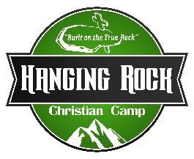
Wilderness Intern
Job Description

Purpose: This person will aid with both Wilderness , Horse, Paintball
Event Coordinators.
Time: May 17 – August 1, 2025
Reports to Maintenance/Wilderness Director
Compensation: $425.00 per week plus room and board
Certification Required: Lifeguard/First Aid/AED

You will be assisting with, and making sure that Wilderness & Paintball, have all their needs met and assist with paintball. Duties including, but not limited to, filling Co2 tanks, cleaning/flipping markers, masks, chest protectors, refereeing games, filling players hoppers, assisting with getting equipment down into paintball area, setting up and taking down speedball inflatable.
- Transporting food to and from main camp to wilderness camp and then serve food.
- Making sure that campers have clean drinking water at cabins, paintball courses, horse camp, retreat center.
- Assist with check-in day. Take mattresses out to cabins, cleaning cabins, making sure trash is empty and ready to go with a new liner, be at front gate of wilderness property to greet parents and campers and hand them parent newsletter.
- Assist with check-out day. Cleaning cabins, porta-pots, mattresses, picking up trash around camp site. Bringing mattresses down from cabins.
- Fogging cabins area, paintball courses, low ropes when groups are going to be using them, vespers area when it will be in use, and pond area prior to use.
- Weed eating around pond, low ropes, cabins, paintball courses, vespers.
- Spraying for weeds around pond, low ropes, cabins, paintball courses, vespers.
- Fill firewood supply at cabins.
- Build fires for campers.
- Help facilitate recreation for smaller wilderness camps.
- May be asked to help in other areas of the camp as well.
_________________________ ____________________________ Wilderness Intern: Executive Director

