Hanging Rock Christian Camp
Kitchen Assistant
Job Description 2026
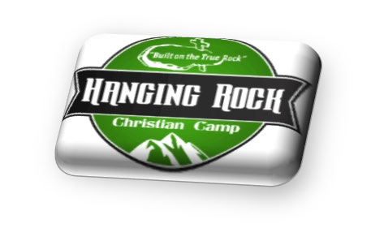
Reports to:
Associate Director

Responsibilities: You will be assisting the cooks for each meal.

Duties: To include but not limited to the following
- Stock dining hall for each meal: salad bar, drink station, napkins, salt & pepper, condiments, etc.
- Clean dining room: wipe tables, sweep, mop, and remove trash after each meal.
- Assist with food prep/clean up
- Assist with dishes if/when needed
- Assist with serving line
- Assist with stocking shelves after deliveries
- Prepare salad bar toppings
- Prepare desserts

Expectations:
- Serve with a smile!!
- Have a Good attitude
- Be a Team player

Time expectations: May 25th- July 31st, 2026
- Breakfast: 7:00 a.m. – 10:00 a.m.
- Lunch: 10:30 – 2:30
- Dinner: 3:30 – 7:30 p.m.

Last day of each camp session: Extra duties
- Pick up tables and chairs
- Deep clean: Sweep & mop dining hall
- Deep clean: Food prep area
- Set up tables and chairs for the next camp
Compensation:
$300 per week + Room & Board

______________________________ _____________________________
Kitchen Assistant Date: Associate Director: Date:

