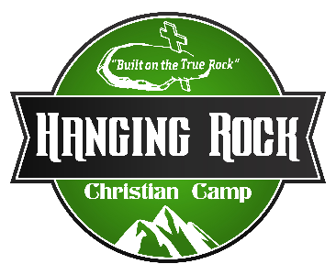
Position Description
Building & Grounds Coordinator

Purpose: This person will aid the Maintenance Director in all areas of Building & Grounds.
Time: Full-Time
Reports to Executive Director/Maintenance Director
Compensation: Salary
Certification Required: CPO-Certified Pool Operator

Main Responsibilities:
- Provide preventative maintenance on all buildings, equipment, and vehicles
- Maintain safety equipment (smoke detectors & fire extinguishers)
- Maintain Pool – Testing & cleaning
- Mowing/Weed eating all our property
- Pond Maintenance
- Deliver water & pool samples weekly/monthly
Miscellaneous Responsibilities:
- Keep Inventory of Maintenance equipment/supplies
- Help if needed to maintain/facilitate recreation elements (zipline, Giant Swing, Rock Wall, Rappelling, Low Ropes & Paint Ball)
- Work with volunteer groups and individuals
- On Call rotation with other staff.
- Any other duties as assigned by Executive Director/Maintenance Director

_________________________ ____________________________
Building & Grounds Coordinator Executive Director

