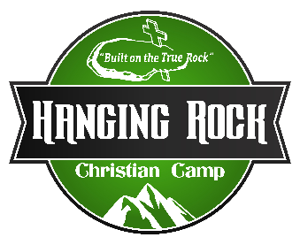
Hanging Rock Christian Camp
Program Staff 2026 Training: May 25-30
Pay $400 per week, plus housing & food

Responsibilities: Will vary but will include all of the following:
- Dorm Resident Assistant: (RA) (you will be sleeping in the dorm)
- Be present at lights out
- Be familiar with dorm parent responsibilities
- Be willing and able to lead nightly devotions and prayer
- Assist with noise levels & problems occurring in the dorms.
- Lock doors at lights out and unlock in the morning
- Oversee discipline in the dorms (You need to be able to handle all kinds of situations)
- Oversee cleaning the dorms at the end of each camp session.
- Lifeguard: To clean pool, shower house, restrooms, and pool filters.
- Set up and get the pool ready, lifeguard daily – This will be on a rotation.
- Perform daily water tests.
- Give swim tests to 6th graders & below
- Recreation: ability to physically perform the duties of this position include catching on the zipline, moving ladders, climbing ladders, etc.
- Facilitate fishing, paddle boats, low ropes, zip-line, rock climbing, rappelling, giant swing, bazooka tag, paintball, archery, bounce house & shooting range.
- The setup and tear down of recreation activities
- Be prepared to lead field games and create new games (if needed)
- Faculty: You might be asked to serve as faculty counselor for weeks that are short on the faculty needs for that camp session. (This includes camps that are on main camp & wilderness camp) If you are needed for faculty that will be your main role for the week.
- (this is not guaranteed only if an event coordinator needs more faculty)
- Work directly with kids and adults of all ages
- Lead family groups
- Counsel campers on spiritual life
- Other Responsibilities:
- There will be times that you might have to weed eat, mow or with help other projects.
- Assist with any other duties as assigned.
Program Director Date Program Staff Date

